**Please convert the data in each table into key-value pair format.**

| **Member** | | | | | |
| --- | --- | --- | --- | --- | --- |
| **Member ID** | **First Name** | **Last Name** | **Phone** | **BirthDate** | **Gender** |
| A10025 | Ron | Ayers | 616-555-4815 | 12/15/1964 | M |
| A10488 | Anna | Clark | 616-555-9912 | 9/3/1994 | F |
| B10216 | Maria | Scott | 616-555-9855 | 2/28/1971 | F |
| B15263 | Calvin | Welmers | 616-555-2598 | 9/5/1983 | M |
| B15674 | Michelle | Ball | 616-555-5612 | 2/2/1987 | F |
| B21845 | Anthony | Geisen | 616-555-2367 | 2/7/1989 | M |

**Answer**:

Key-value pair format for Member table is as follows:

Member:A10025:First_Name=”Ron”

Member:A10025:Last_Name=”Ayers”

Member:A10025:phone=”616-555-4815”

Member:A10025:BirthDate =”12/15/1964”

Member:A10025:Gender=”M”

Member: A10488:First_Name=”Anna”

Member: A10488:Last_Name= Clark”

Member: A10488:phone=”616-555-9912”

Member: A10488:BirthDate =”9/3/1994”

Member: A10488:Gender=”F”

Member: B10216:First_Name=” Maria”

Member: B10216:Last_Name=”Scott”

Member: B10216:phone=”616-555-9855”

Member: B10216:BirthDate =”2/28/1971”

Member: B10216:Gender=”F”

Member: B15263:First_Name=” Calvin”

Member: B15263:Last_Name=”Welmers”

Member: B15263:phone=”616-555-2598”

Member: B10216:BirthDate =”9/5/1983”

Member: B10216:Gender=”M”

Member: B15674:First_Name=” Michelle”

Member: B15674:Last_Name=” Ball”

Member: B15674:phone=”616-555-5612”

Member: B15674:BirthDate =”2/2/1987”

Member: B15674:Gender=”F”

Member: B21845:First_Name=” Anthony”

Member: B15674:Last_Name=” Geisen”

Member: B15674:phone=”616-555-2367”

Member: B15674:BirthDate =”2/7/1989”

Member: B15674:Gender=”M”

2.

| **TID** | **FirstName** | **LastName** | **Specialty** | **Certification** | **HireDate** | **Interests** |
| --- | --- | --- | --- | --- | --- | --- |
| 312 | Randy | Lee | Strength Training | RYT | 9/27/2013 | yoga, nutrition |
| 585 | Cam | Williams | Sports Medicine | NASM | 6/10/2014 | nutrition, martial arts |
| 704 | Melissa | Rogers | Strength Training | NSCA-CSCS | 6/15/2015 | sports medicine, yoga |
| 709 | Richard | Sanderson | Sports Medicine | NASM | 6/1/2016 | strength training, swimming |

**Answer:**

Key-value pair for the trainer table(above table) is as follows:

TID:312:FirstName=”Randy”

TID:312:LastName=”Lee”

TID:312:Speciality=”Strength Training”

TID:312:Certification=”RYT”

TID:312:Hiredate=”9/27/2013”

TID:312:Interests=”yoga, nutrition”

TID:585:FirstName=”Cam”

TID:585:LastName=”Williams”

TID:585:Speciality=”Sports Medicine”

TID:585:Certification=”NASM”

TID:585:Hiredate=”6/10/2014”

TID:585:Interests=”nutrition, martial arts”

TID:704:FirstName=”Melissa”

TID:704:LastName=”Rogers”

TID:704:Speciality=”Strength Training”

TID:704:Certification=”NSCA-CSCS”

TID:704:Hiredate=”6/15/2015”

TID:704:Interests=”sports medicine, yoga”

TID:709:FirstName=”Richard”

TID:709:LastName=”Sanderson”

TID:709:Speciality=”Sports Medicine”

TID:709:Certification=”NASM”

TID:709:Hiredate=”6/1/2016”

TID:709:Interests=”strength training, swimming”

3.

| **Billing** | | | | | | |
| --- | --- | --- | --- | --- | --- | --- |
| **BillingID** | **MemberID** | **TrainerID** | **StartDate** | **EndDate** | **Amount** | **Sessions** |
| A80342 | A10025 | 704 | 3/7/2016 | 3/28/2016 | $1,000.00 | 10 |
| B80345 | A10488 | 312 | 3/28/2016 | 4/18/2016 | $1,000.00 | 10 |
| A80610 | B10216 | 585 | 4/1/2016 | 5/17/2016 | $1,200.00 | 12 |
| A80643 | B10216 | 312 | 2/2/2016 | 2/18/2016 | $950.00 | 7 |
| A80565 | B15263 | 585 | 2/1/2016 | 2/17/2016 | $600.00 | 6 |
| B85659 | B15674 | 709 | 4/22/2016 | 5/22/2016 | $450.00 | 4 |
| A80214 | B21845 | 585 | 2/5/2016 | 5/3/2016 | $850.00 | 7 |

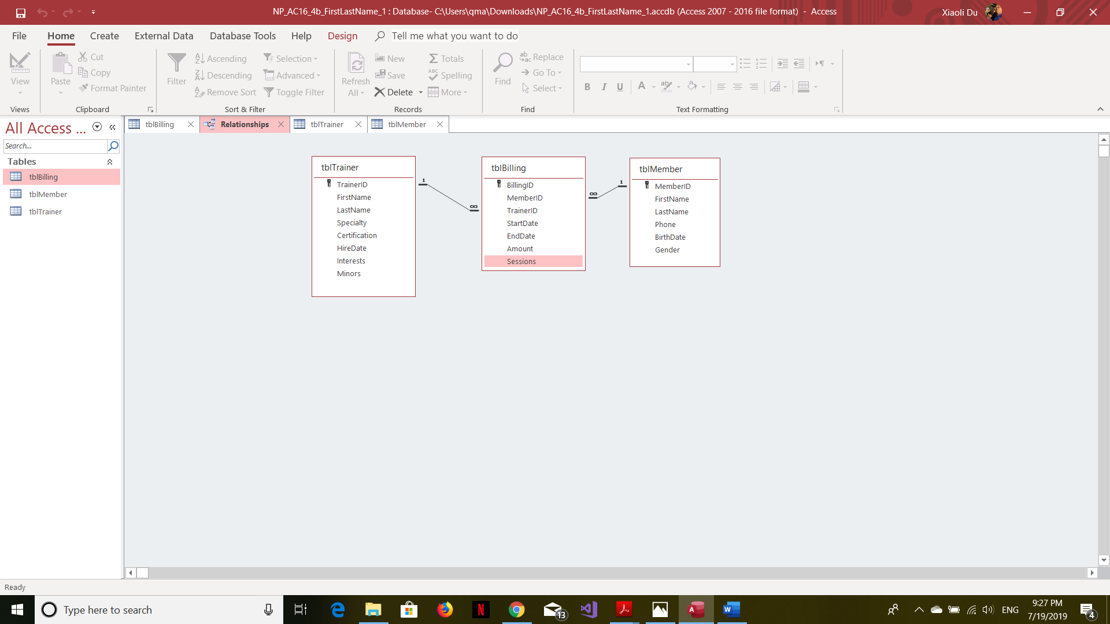

**Answer:**

Key value for Billing table:

Billing:A80342:A10025:704:StartDate=”3/7/2016”

Billing:A80342:A10025:704:EndDate=”3/28/2016”

Billing:A80342:A10025:704:Amount=”$1,000.00”

Billing:A80342:A10025:704:Sessions=”10”

Billing:A80345:A10488:312:StartDate=”3/28/2016”

Billing:A80345:A10488:312:EndDate=”4/18/2016”

Billing:A80345:A10488:312:Amount=”$1,000.00”

Billing:A80345:A10488:312:Sessions=”10”

Billing: A80610: B10216:585:StartDate=”4/1/2016”

Billing: A80610: B10216:585:EndDate=”5/17/2016”

Billing: A80610: B10216:585:Amount=”$1,200.00”

Billing: A80610: B10216:585:Sessions=”12”

Billing: A80643: B10216:312:StartDate=”2/2/2016”

Billing: A80643: B10216:312:EndDate=”2/18/2016”

Billing: A80643: B10216:312:Amount=”$950.00”

Billing: A80643: B10216:312:Sessions=”7”

Billing: A80565: B15263:585:StartDate=”2/1/2016”

Billing: A80565: B15263:585:EndDate=”2/17/2016”

Billing: A80565: B15263:585:Amount=”$600.00”

Billing: A80565: B15263:585:Sessions=”6”

Billing B85659:B15674:709:StartDate=”4/22/2016”

Billing:B85659:B15674:709:EndDate=”5/22/2016”

Billing:B85659:B15674:709:Amount=”$450.00”

Billing:B85659:B15674:709:Sessions=”4”

Billing:A80214: B21845:585:StartDate=”2/5/2016”

Billing A80214: B21845:585:EndDate=”5/3/2016”

Billing:A80214: B21845:585:Amount=”$850.00”

Billing:A80214: B21845:585:Sessions=”7”